Networks Sub-module Assignment Answers for Part 2

George Mathachan
xbkt52

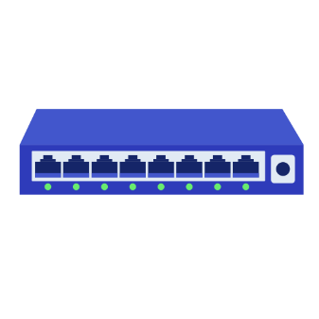
- Sketch a topology to accurately reflect the connections of the network described above. Your topology should include all devices mentioned and their connections.

Port 8
Port 7
Port 5
Port 4
Port 6
Port 3
Port 2
Port 1


X
S
A



B

C

- Which wireless user devices above can receive the frame sent by C? Why?

The wireless user devices A and B can receive the frame sent by C. This is because C sends the frame to the 2-layer switch S and subsequently S floods the frame out of all ports (except the incoming port – port 8).So the frame reaches port 1 (the access point). Crucially, the wireless scheme used here is CSMA/CA without acknowledgements meaning there is no filtering based on who ‘should’ hear it. Therefore, X broadcasts the frame over the shared wireless medium, and both A and B are within X’s coverage and can hear its transmissions.

- At what time does A start sending its frame (i.e., putting the frame on the transmission medium) to X? At what time does B start sending its frame to X? At what time does C’s frame arrives at the destination? Explain.

At 0μs C starts sending its frame to X. This takes 30μs. So at 30μs X receives C’s frame.
At 20μs A frame becomes available for transmission from A to C. The signal is detected as idle (because C’s frame, although it started transmission first, has not reached X yet). So, A waits 5μs (DIFS). The signal is still idle so A’s backoff timer begins (at 25μs), counts down for 5μs, and is frozen when X starts transmitting at 30μs. This takes 20μs. C’s frame reaches its destination at 50μs.
At time 40μs, a frame from B was ready for transmission, but the signal was busy so its DIFS couldn’t start.
At time 50μs the signal becomes idle again. A and B start their DIFS. This lasts until time - 55μs. A resumes it backoff timer, while B starts its backoff timer. B’s backoff timer is 11μs and A has only 3μs left on its backoff timer. Therefore, at time 58μs, A begins to transmit its frame. This lasts 60μs until time - 119μs. At this point, B starts its DIFS until 124μs and continues its backoff timer – a further 8μs – until 131μs. So B starts to transmit its frame at time - 131μs, and this lasts until 212μs.
C’s frame arrives at the destination at 50μs.
A starts to send its frame at 58μs.
B starts to send its frame at 131μs.

- Give the switching table of S at 84 us. Explain

MAC Address | Port
 | Port 1
 | Port 2
 | Port 3
 | Port 4
 | Port 5
 | Port 6
 | Port 7
 | Port 8

- If you connect a computer to port 2 of S, which frame(s) can you receive from all the above processes? Explain.

